**The appendix**

Figure1

The amount of arts for different years

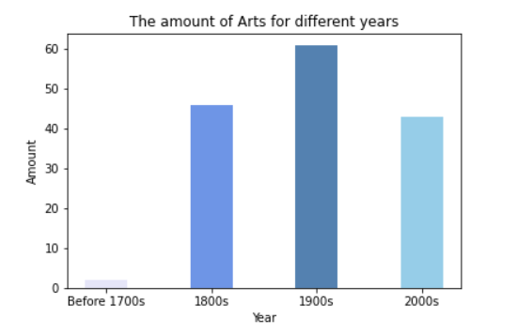

Shows the general number of arts in different years.

Figure2

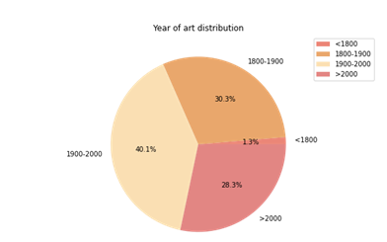

Shows the ratio of the number of artworks appearing in different years

Figure3

Public art heatmap

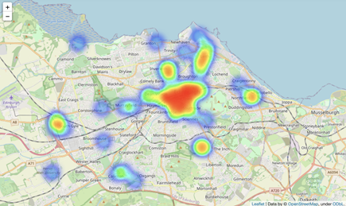

Displays the spatial density of the artwork.

Figure4 Physical map

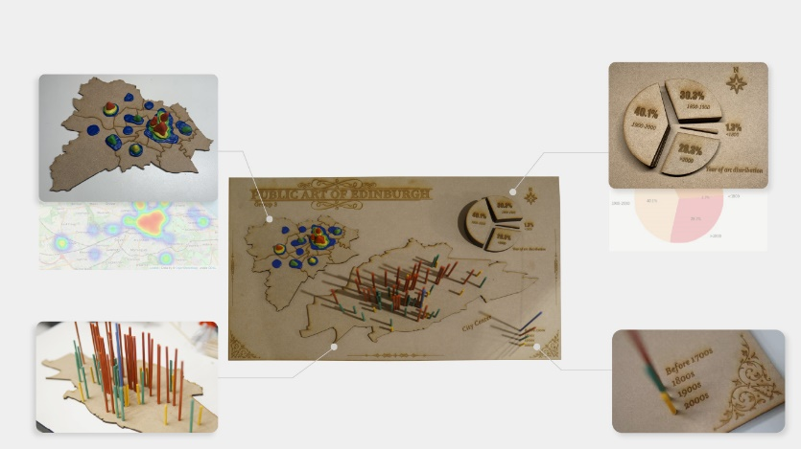

Zoom in the various parts of our map

Figure 5 Art position

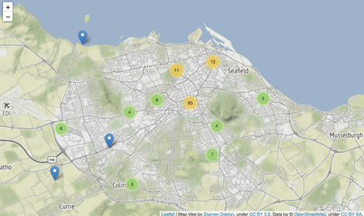

Shows the general positions information of arts in different centuries.

Figure 6

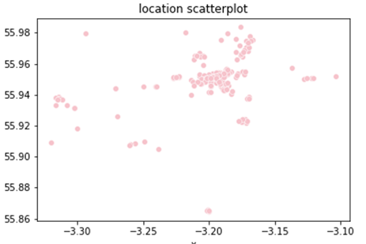

Shows different public arts in Edinburgh’s space distribution.